EN Capra Industry Oy/Ab

EU Declaration of Conformity



This declaration of conformity is issued under the sole responsibility of the manufacturer Capra Industry Oy/Ab. The object described is in conformity with Union harmonization legislation Personal Protective Equipment (PPE) Regulation EU 2016/425.

C307

**Medium risk**



**REFERENCES TO HARMONIZED STANDARDS TO WHICH CONFORMITY IS DECLARED** EN 388:2016+A1:2018, EN 511:2006, EN ISO 21420:2020

**IDENTIFICATION/ CERTIFICATION NUMBER** 0075/4510/162/01/24/0007

**CERTIFICATION DATE** 05 January 2024

**CERTIFICATION EXPIRY DATE** 05 January 2029

**EU-TYPE EXAMINATION** C.T.C (0075), 4 rue Hermann Frenkel, 69367 LYON Cedex 07 FRANCE.

DATED 31.05.2024

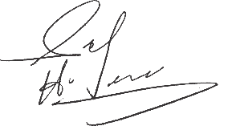

Hafiz Saleem Zaka

*Product Manager,*

Capra Industry Oy/Ab,

Espoo Finland.

Capra Industry Oy/Ab

Kutojantie 3, 02630 Espoo, Finland

Phone +358 (0)406832695

VAT No: FI31408367

[cs@capra.fi](mailto:cs@capra.fi)